PREPARATORY DOCUMENT FOR MOBILE PREPAID RECHARGE PROJECT

1. Project Overview
Project Name: Mobile Prepaid Recharge
My Website Name: PreZee (Prepay easily)
Purpose and Goals:
To design and develop an end-to-end multi-tiered web-based solution for prepaid mobile recharge services, enabling users to recharge their mobile plans efficiently while providing administrators with tools to manage subscribers, plans and recharge histories. The goal is to create a scalable, secure, and user-friendly application using modern web technologies.
Expected Outcomes:
- A fully functional single-page application (SPA) deployed on a public cloud platform.
- Seamless recharge experience for prepaid mobile users with multiple payment options.
- Admin capabilities to monitor and manage subscriber recharge statuses.
- Source code maintained on GitHub with continuous integration.

2. Scope & Objectives
Features to be Included:
- User authentication and role-based access (Admin and Subscribers).
- Display of recharge plans (Popular Plans, Validity Plans, Data Plans, Unlimited Data Plans).
- Payment simulation with options like UPI, Bank Transfer, Credit/Debit Card.
- Email confirmation after successful recharge.

- Email sends to concern user regarding expiring plan.
- Responsive web design using Bootstrap.
- Admin CRUD operations via REST APIs with Spring Boot and Spring-Data JPA.
Features Explicitly Excluded:
- Real payment gateway integration (dummy payment simulation only).
- Support for postpaid mobile recharge.

3. Technical Specifications
Tech Stack:
Frontend: HTML5, CSS3, Bootstrap, JQuery.
Backend: Java, Spring Boot, JPA, RESTful Services, Await, Fetch.
Database: MySQL.
Tools: JDK, Maven.
Architecture Overview:
- Microservices-based architecture with Spring Boot for backend services.
- Single Page Application (SPA) frontend communicating with backend via REST APIs.
- Database layer managed through JPA with parameterized stored procedures (RDBMS).
Integration Details:
  - REST APIs for data exchange between the frontend and the backend.
  - Simulated payment processing using Razor pay.
  - Email service integration for recharge confirmation using Java Mail.
  - OTP is simulated using Twilio for profile validation purpose.

4. User Roles & Functionalities
User Roles:

Admin:
Manages Subscribers, Plans and views recharge histories.

Subscribers (Prepaid Mobile User):
Recharges mobile plans and views available plans.
Functionalities:
Admin:
  - View list of subscribers with plans expiring within 3 days.
  - Notify user regarding plan expiry
  - Plan management like create category, create plan, delete plan, edit plan.
  - Generate Report.
Prepaid Mobile User (Subscribers):
- Enter mobile number.
- View plans, Select plans, and recharge plans.
- Choose a payment method and simulate payment.
- Receive confirmation email.

5. Data Flow & Structure
Data Structure
The system consists of several entities mapped to database tables using JPA annotations. These entities represent the core components of a subscription/recharge system, including subscribers, admins, plans, categories, payments, and transaction histories. Here's a breakdown of the structure:
Entities and Their Relationships

1. Subscriber
  - Table : Subscribers
  - Fields : subscriber_id (PK), mobile (unique), email (unique), name , password , status (enum: ACTIVE , INACTIVE )
  - Purpose : Represents a user who subscribes to plans.
  - Relationships :
  - One-to-Many with PlanHistory , RechargeHistory , and TransactionHistory (a subscriber can have multiple recharge/transaction records).

2. Admin
  - Table : Admins
  - Fields : admin_id (PK), username (unique), password , email (unique), created_at
  - Purpose : Represents an administrator managing the system.
  - Relationships : None explicitly defined.

3. Category
  - Table : Categories
  - Fields : category_id (PK), name (unique), created_at , plans (list)
  - Purpose : Groups plans into categories (e.g., "Mobile Recharge", "Broadband").
  - Relationships :
  - One-to-Many with Plan (a category can have multiple plans).

4. Plan
  - Table : Plans
  - Fields : plan_id (PK), category_id (FK), details , amount , validity_days , created_at
  - Purpose : Defines subscription plans available for subscribers.

  - Relationships :
  - Many-to-One with Category (a plan belongs to one category).

  - One-to-Many with PlanHistory and RechargeHistory (a plan can be subscribed to multiple times).

5. Payment
  - Table : payment
  - Fields : payment_id (PK), pay_name , amount , status (enum: PENDING , SUCCESS , FAILED )
  - Purpose : Stores payment details for a recharge.
  - Relationships : One-to-One with RechargeHistory (each recharge has one payment).

6. PlanHistory
  - Table : plan_history
  - Fields : recharge_id (PK), subscriber_id (FK), plan_id (FK), amount , payment_mode , validity_start , validity_end , recharge_date
  - Purpose : Tracks the history of plans subscribed by a user, including validity periods.
  - Relationships : Many-to-One with Subscriber and Plan .

7. RechargeHistory
  - Table : Recharge_History
  - Fields : recharge_id (PK), subscriber_id (FK), plan_id (FK), payment_id (FK), recharge_date , amount , validity_start , validity_end
  - Purpose : Records completed recharges with payment and validity details.
  - Relationships :
  - Many-to-One with Subscriber and Plan .
  - One-to-One with Payment .

8. TransactionHistory
  - Table : transaction_history
  - Fields : transaction_id (PK), subscriber_id (FK), planName , planId , category , details , amountPaid , paymentMode , transactionDate
  - Purpose : Logs detailed transaction records for reporting or auditing.
  - Relationships :
  - Many-to-One with Subscriber .

9. Non-Entity Classes (DTOs)
  - PaymentRequest : Used to capture payment initiation details (e.g., payment mode, UPI, card details).
  - PaymentResponse : Response object for payment processing (success/failure, transaction details).
  - PaymentVerificationRequest : Used for verifying payment (e.g., Razorpay integration).

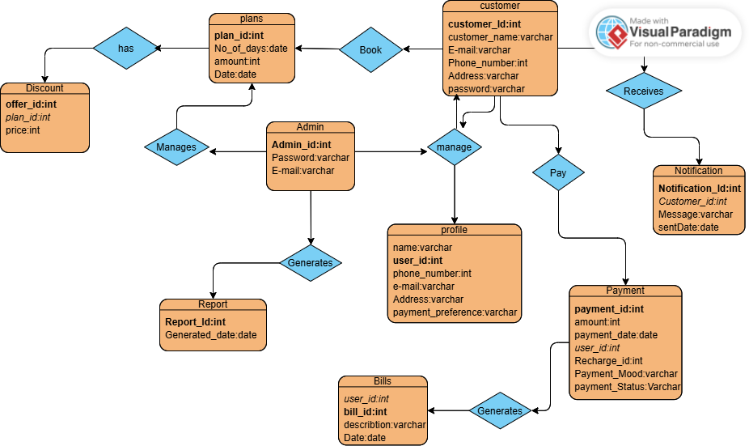

6. Development Approach
Methodology: Agile with iterative sprints.
Development Phases :
1. Phase 1 : Requirement analysis and design (ERD, API specs).
2. Phase 2 : Frontend development (HTML, CSS, Bootstrap).
3. Phase 3 : Backend development (Spring Boot REST APIs, JPA).
4. Phase 4 : Integration and testing(Junit, Mockito).
5. Phase 5 : Deployment on cloud platform (Netlify).

7. Risk Assessment & Mitigation
Security Breaches: Unauthorized access to APIs.
Mitigation: Implement JWT-based authentication and HTTPS Session Handling.

8. Testing Strategy and Logging
Unit Testing :
JUnit and Mockito for backend logic (e.g., service and controller layers).
Integration Testing :
Postman for testing REST API endpoints.
User Acceptance Testing :
Test with real mobile numbers.
Logging :
Use Logback for application logs to track errors and transactions.

9. Project Timeline & Milestones
Milestones:
1. Day 1 : Design documentation and setup.
2. Day 2 : Frontend development and integration.
3. Day 3 : Backend API development and database setup.
 | Start Date | End Date
UI/UX design | 12/02/2025 | 13/02/2025
Phase I | 14/02/2025 | 20/02/2025
Phase II | 12/03/2025 | 21/03/2025

